## Process to call web service in Pipeline Pilot

1. Create one New Protocol from File -> New Protocol
2. Go to Components tab
3. Search with keyword wsdl, you will find results as below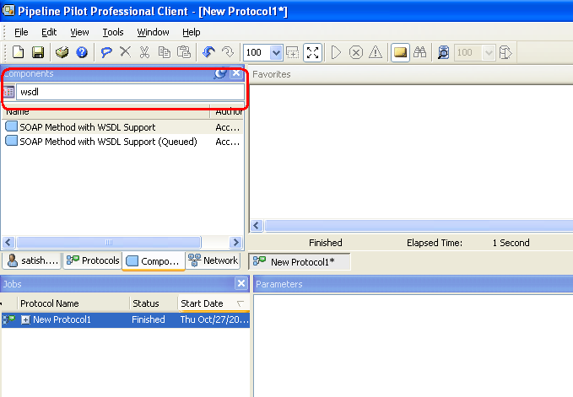
4. Double click on SOAP Method with WSDL Support, this component will be added into Favorites tab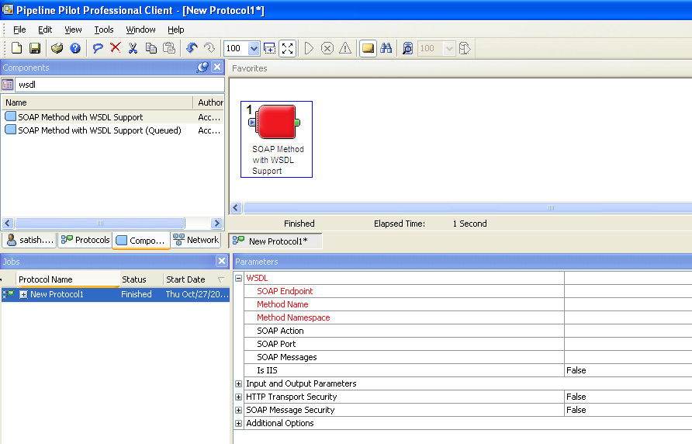
5. In parameters tab click on the wsdl properties button marked in below snap shot.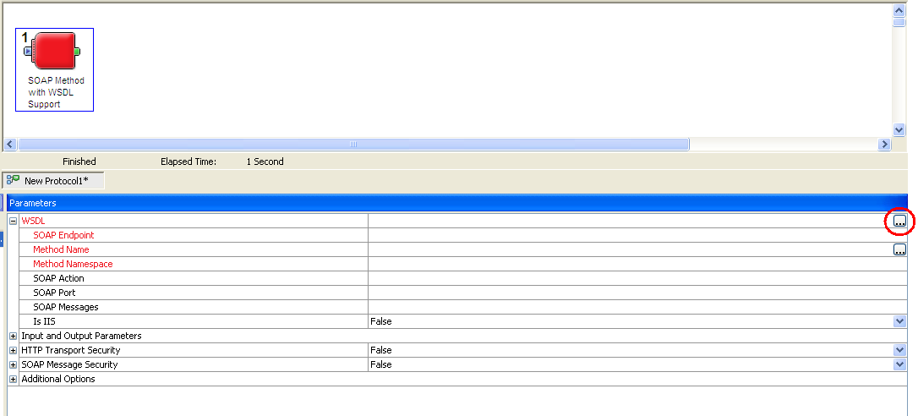
6. Wsdl properties window is shown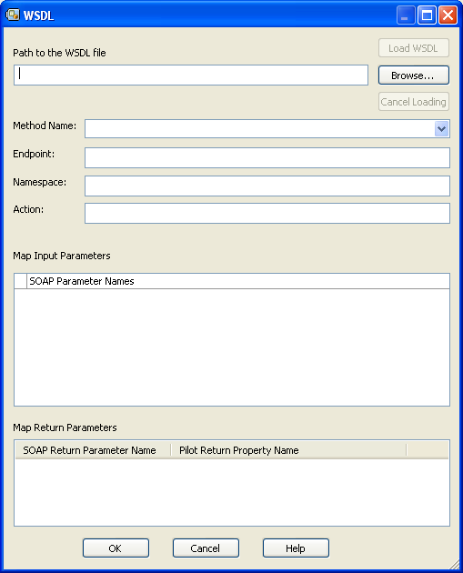
7. Paste web service URL path in Path to WSDL file and click on Load WSDL. You will see details as in below snap shot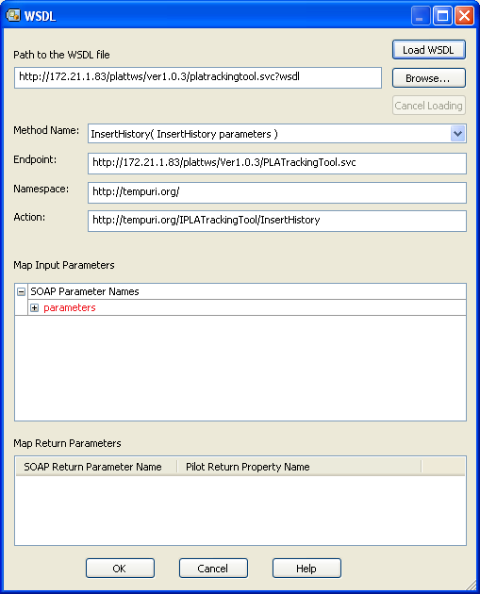
8. Change Method Name to InsertHistoryPP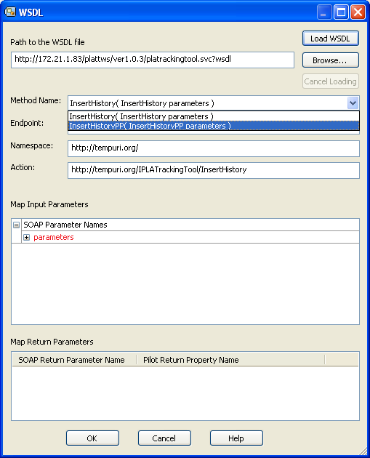
9. In Map Input Parameters, expand parameters, you will see all 4 input parameter of web service. Since webservice returns value you will see return parameters in Map Return Parameters below.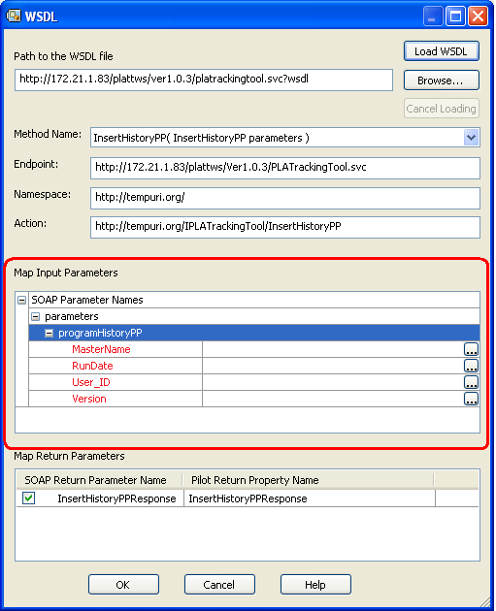
10. Now enter values for 4 parameters, parameters should be entered with single quote for string inputs and click OK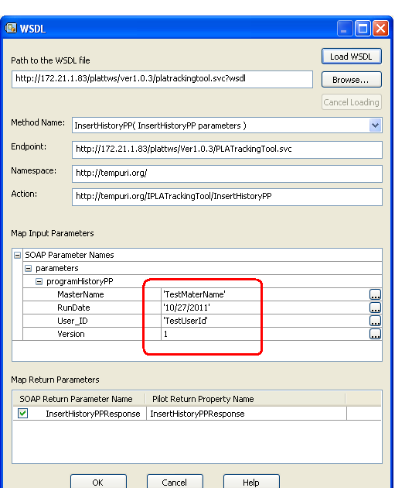
11. You can see all the parameters are loaded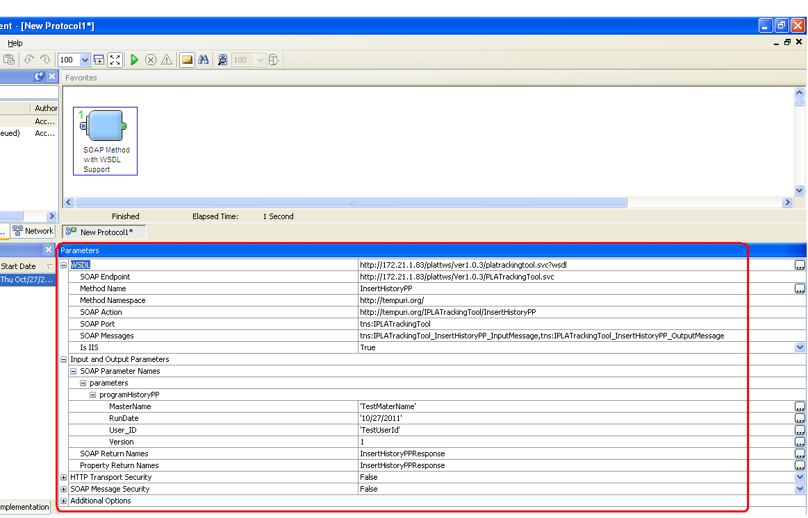
12. Click on Run button, now webservice will run and execute the webservice. After you see Finished status, now you can check the values in database, the values should be inserted.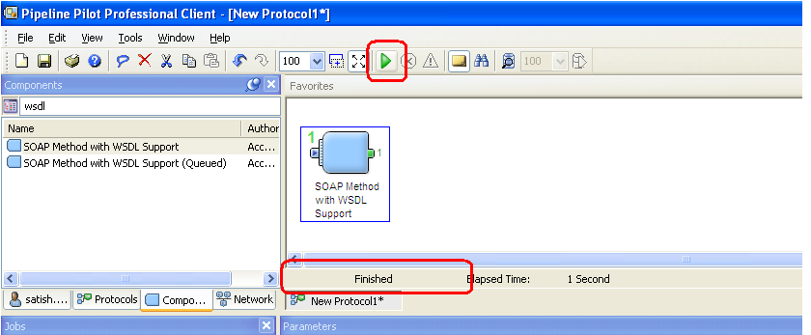
13. If you want to view the return value from web service. Search for Notepad View in components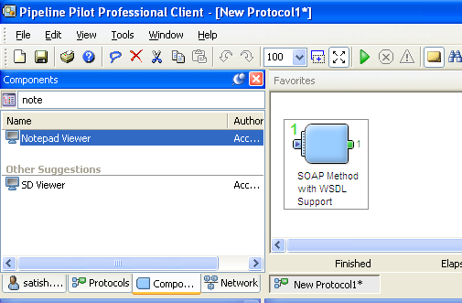
14. Double click on Notepad Viewer. It will be attached to SOAP component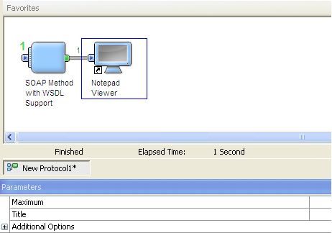
15. Now click on Run button. You will get output message in a notepad